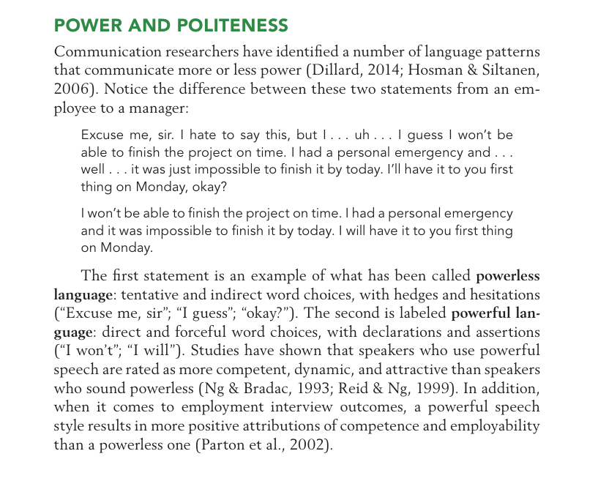

**THE LANGUAGE OF RESPONSIBILITY**

Besides providing a way to make the content of a message clear or obscure, language reflects the speaker’s willingness to take responsibility for her or his beliefs, feelings, and actions. This acceptance or rejection of responsibility says a great deal about the speaker, and it can shape the tone of a relationship.

To see how, read on. “It” Statements Notice the difference between the sentences in each set:

“It’s worrying when you’re late.”

“I’m worried when you’re late.”

“It’s a bad idea.”

“I don’t think that’s a good idea.”

“It’s a problem.”

“I see it as a problem.”

As their name implies, “it” statements replace the personal pronouns I and me with the less immediate construction it’s. By contrast, “I” language clearly identifies the speaker as the source of a message. Communicators who use “it” statements avoid ownership of a message. This habit isn’t just imprecise; it’s a subtle, potentially unconscious way for someone to avoid taking a position.

